

2D-3D Lifting for Multiview Pedestrian Detection
Class: Duration time: from 09/2026 to 12/2026

(*) Profession: <AI Engineer> | Specialty: | CV 🗹 | NLP □ |  | DS □ | Other □
(*) Kinds of person make registers: |  | Lecturer 🗹 |  | Students □ |  | Other □

Register information for supervisor (if have)

 | Full name | Phone | E-Mail | Title
Supervisor 1 | Đào Duy Sơn |  | SonDD7@fe.edu.vn | Mr.
Register information for students (if have)

 | Full name | Student code | Phone | E-mail | Role in Group
Student 1 |  |  |  |  | leader
Student 2 |  |  |  |  | member
Student 3
Student 4

Register content of Capstone Project (*) 3.1. Capstone Project name:

English: 2D-3D Lifting for Multiview Pedestrian Detection
Vietnamese: Nâng từ 2D sang 3D trong hệ thống nhiều camera phát hiện người đi bộ
Abbreviation: MVDet-3D
Describe:
Multiview pedestrian detection localizes people on a common ground plane using several calibrated cameras with overlapping fields of view. Compared with monocular detection, the multiview setting resolves heavy occlusion in crowded scenes, because a person hidden in one view is usually visible in another. The central challenge is how to fuse information across views into a single, geometrically consistent representation.
The dominant paradigm projects per-camera image features onto the ground plane via a perspective (homography) transformation and aggregates them into a bird's-eye-view (BEV) occupancy map. However, a flat ground-plane projection collapses all vertical structure onto a single height and misaligns features that do not lie on the ground, producing "smearing" artifacts. This project investigates lifting 2D image features into a shared 3D voxel volume — modelling that pedestrians occupy vertical extent — before decoding occupancy, for more accurate and occlusion-robust detection.
Solutions to this problem involve four major steps:
- Per-view feature extraction — encode each camera image with a CNN or transformer backbone.
- 2D-to-3D lifting — project or predict image features into a shared 3D volume using the known calibration.
- Multiview aggregation — fuse the lifted volumes across cameras (e.g., averaging or attention).
- BEV occupancy decoding — decode the aggregated volume into ground-plane pedestrian detections.
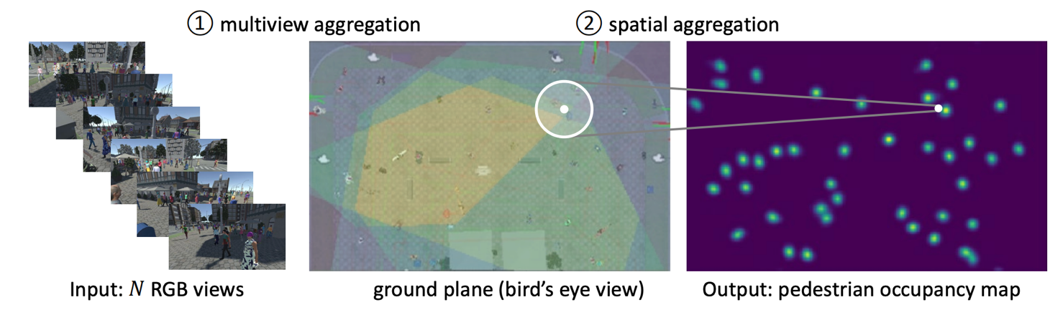
Figure 1: Multiview pedestrian detection localizes people on a common ground plane using several calibrated cameras with overlapping fields of view. Source [1]

Context:
Standard benchmarks are WildTrack [3] and MultiviewX [1]. MVDet [1] introduced feature-perspective-transformation to the ground plane; MVDeTr [2] added a shadow/deformable transformer to reduce projection artifacts. Both operate essentially in a 2D BEV plane.
By explicitly lifting features to 3D, we aim to better model occlusion and object height and to outperform these baselines on MODA and MODP. In this capstone we use WildTrack [3] and MultiviewX [1] for training and testing and propose a 3D-lifting aggregation to replace or augment the flat ground-plane projection.
Objectives:
- Deep-learning approaches for multiview pedestrian detection based on 2D-to-3D feature lifting.
- Evaluation on WildTrack and MultiviewX with the standard train/test split (MODA, MODP, precision, recall).
(*) 3.2. Main proposal content (including result and product)
Theory and practice (document):
- Research multiview detection pipelines and propose a novel 3D-lifting aggregation, together with improvements to feature encoding, cross-view fusion and BEV decoding. State-of-the-art backbones and attention mechanisms may be applied for better performance.
- Students should apply their knowledge from computer vision, deep learning and programming skills gained from their curriculum while carrying out the capstone.
References:
- [1] Hou, Y., Zheng, L. & Gould, S. (2020). "Multiview Detection with Feature Perspective Transformation." In ECCV.
- [2] Hou, Y. & Zheng, L. (2021). "Multiview Detection with Shadow Transformer (and View-Coherent Data Augmentation)." In ACM Multimedia.
- [3] Chavdarova, T. et al. (2018). "WILDTRACK: A Multi-camera HD Dataset for Dense Unscripted Pedestrian Detection." In IEEE/CVF CVPR.

Supervisor (If have)
(Sign and full name)
HCM, 07/2026

On behalf of Registers
(Sign and full name)

